Design Document: Exogredient

Team A

Jason Nguyen (Team Leader) - 014232658

Eleazar Gomez - 012465490

David Nguyen - 015633187

Abe Malla - 016069649

Charles Kwak - 015368728

Hovhannes Babuchyan - 017228651



November 12, 2019

Table of Contents

**Features** **3**

Upload - Create An Upload 3

Upload - Save Progress Of An Upload 3

Upload - Delete Progress Of An Upload 4

Upload - Continue Progress Of An Upload 5

Upload - Delete Own Upload 5

Report An Upload 6

Search For An Ingredient 6

Comment On An Upload 7

Search For A Store 8

Claim Store 8

Upvote / Downvote (Upload Or Store Owner’s Description) 9

Display Profile View 10

Admin Delete Upload 10

Display Manage Store View. 11

Manage Store - Flag / Unflag An Ingredient In Their Store 11

Manage Store - Advertisement 12

Manage Store - Submit Description Of An Ingredient 12

Manage Store - Unclaim Store 13

Verify An Upload 14

Ingredient Save List - Add To Save List 14

Ingredient Save List - Delete From Save List 15

Ingredient Save List - View Item From Save List 15

Registration 16

Authentication - Login 17

Authentication - Logout 18

Authentication - Reset Password 18

Authorization 20

Logging 20

Archiving 20

Error Handling 21

# 

# Features

——————————————————————————————————————————

## Upload - Create An Upload

Preconditions:

* Must be logged in.
* Must be at the Upload View.

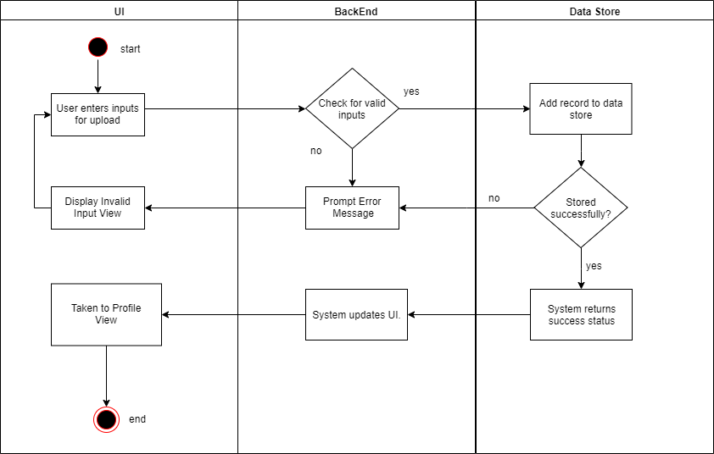

## Upload - Save Progress Of An Upload

Preconditions:

* Must be logged in.
* Must be at the Upload View.

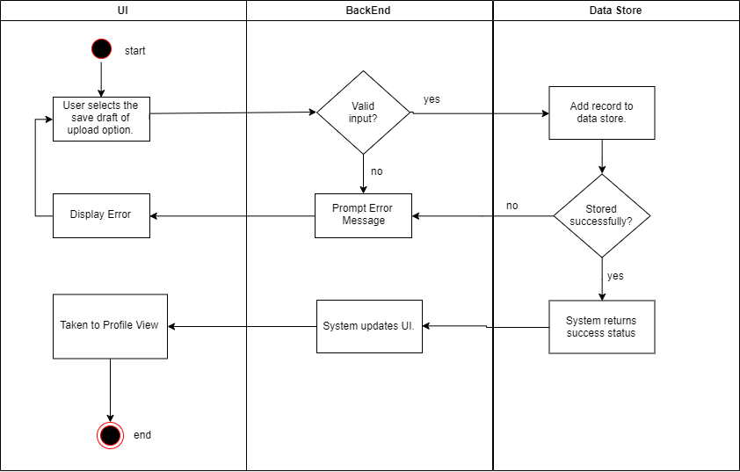

## Upload - Delete Progress Of An Upload

Preconditions:

* Must be logged in.
* Must have a saved Upload draft.
* Must be at the Profile View.

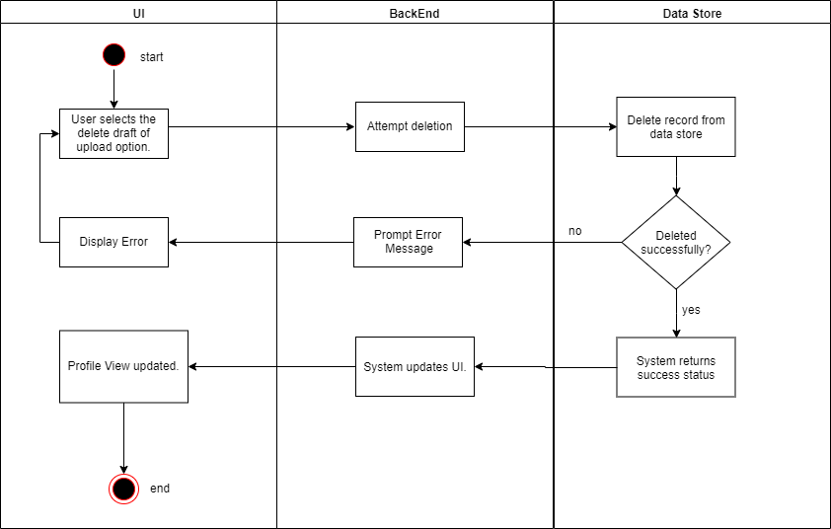

## Upload - Continue Progress Of An Upload

Preconditions:

* Must be logged in.
* Must have a saved Upload draft.
* Must be at the Profile View.

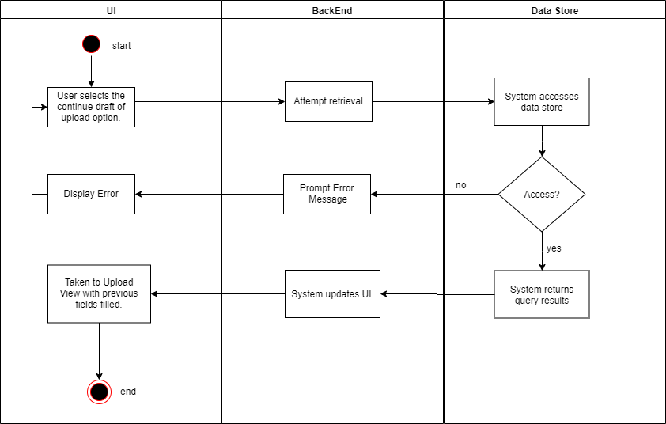

## Upload - Delete Own Upload

Preconditions:

* Must be logged in.
* Must be at the Profile View.

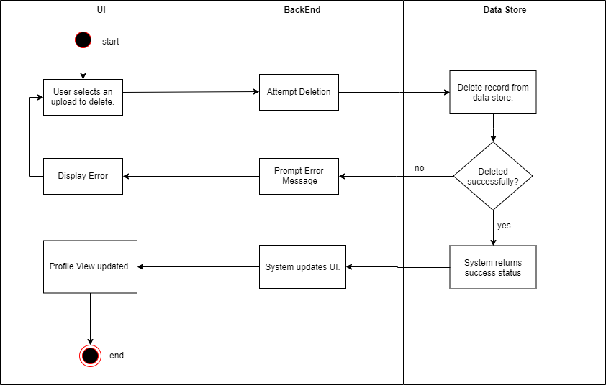

## Report An Upload

* Must be logged in.
* Must be at the Ingredient View.

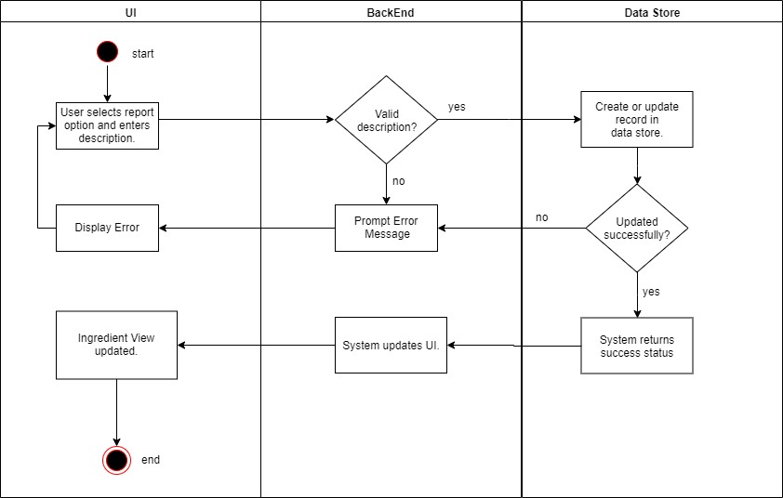

## Search For An Ingredient

Preconditions:

* Must be at the Home View.

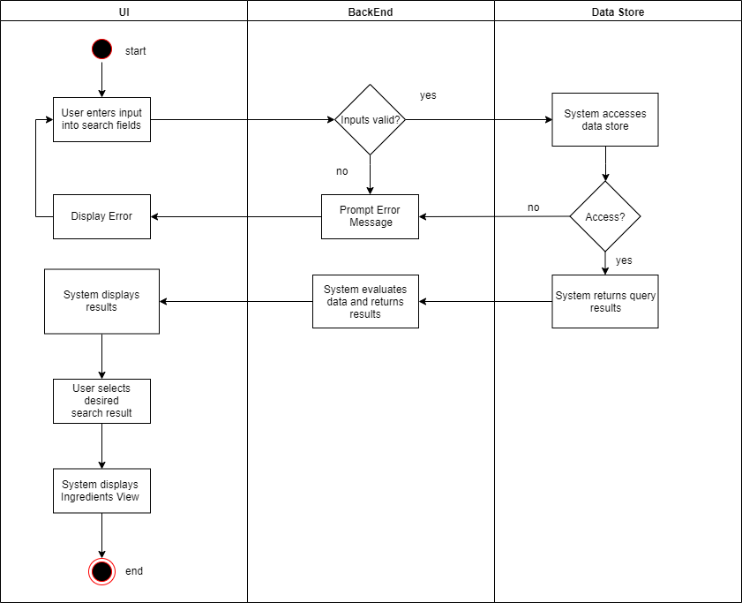

## Comment On An Upload

Preconditions:

* User must be logged in.
* User must be at an Ingredient View.

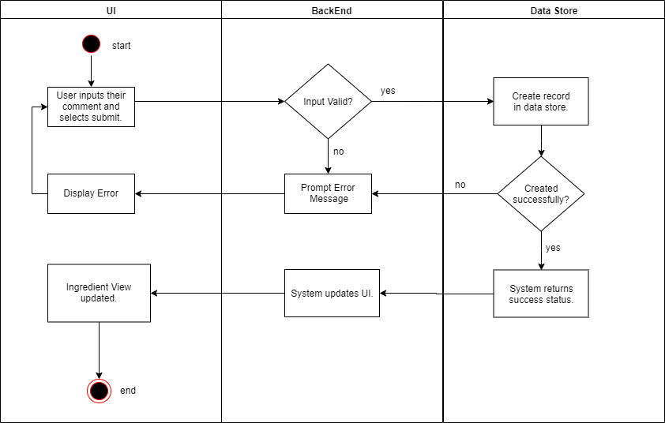

## Search For A Store

Preconditions:

* User must be at the Home View.

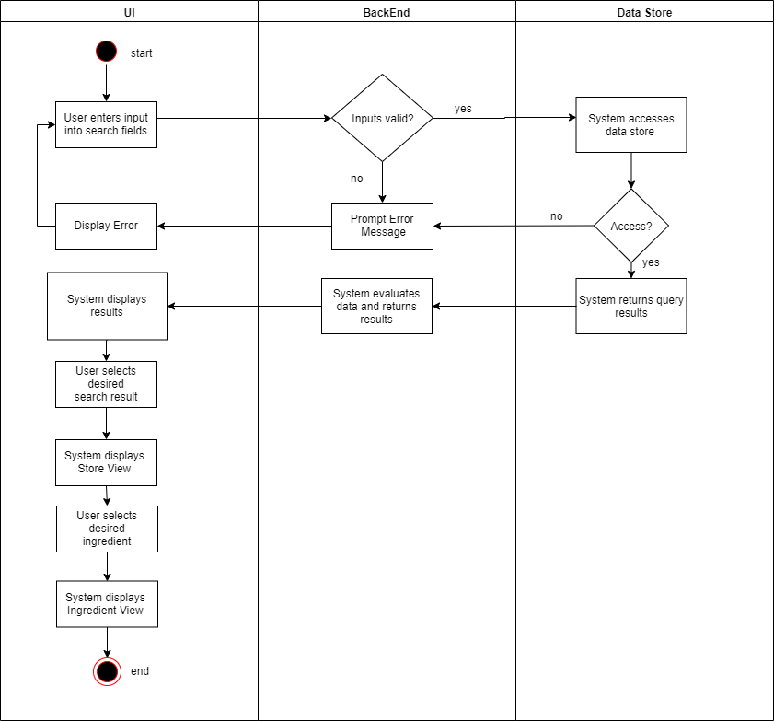

## Claim Store

Preconditions:

* User must be logged in.
* User must be on an unclaimed store’s Store View.

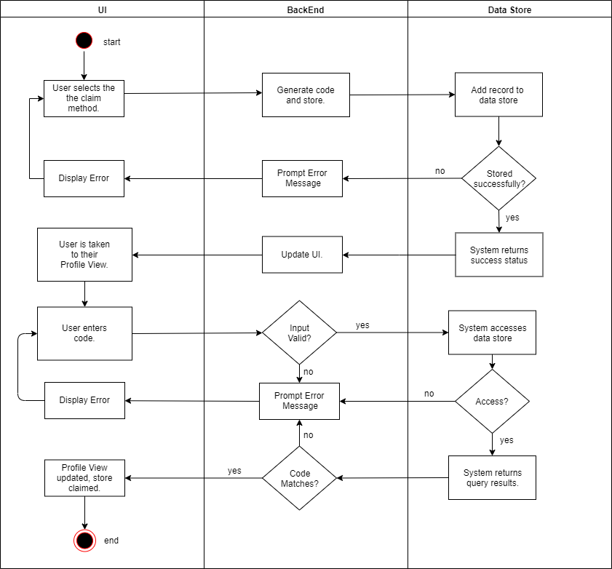

## Upvote / Downvote (Upload Or Store Owner’s Description)

Preconditions:

* Must be logged in.
* Must be at an Ingredient View.

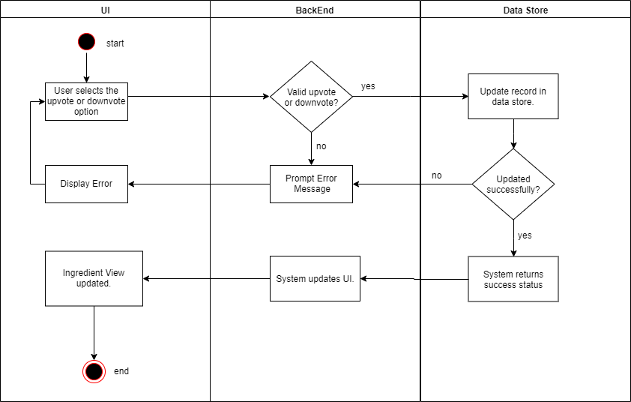

## Display Profile View

Preconditions:

* User must be logged in.
* User must be at the Home View.

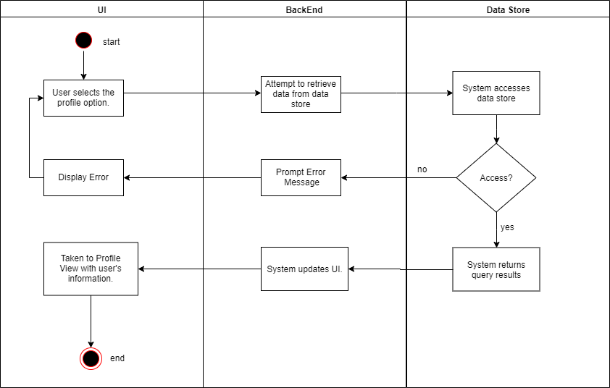

## Admin Delete Upload

Preconditions:

* User must be logged in with admin privileges.
* User must be at an Ingredient View.

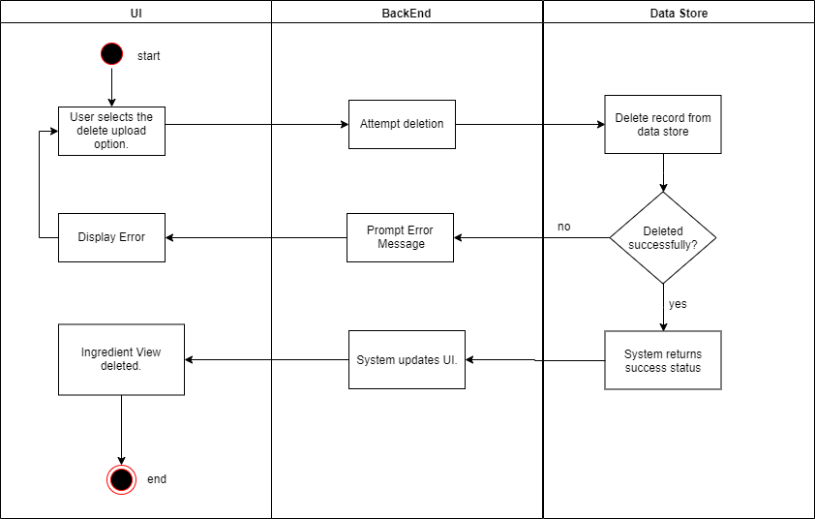

## Display Manage Store View.

Preconditions:

* User must be logged in and have Store Owner privileges.
* User must be at the Profile View.

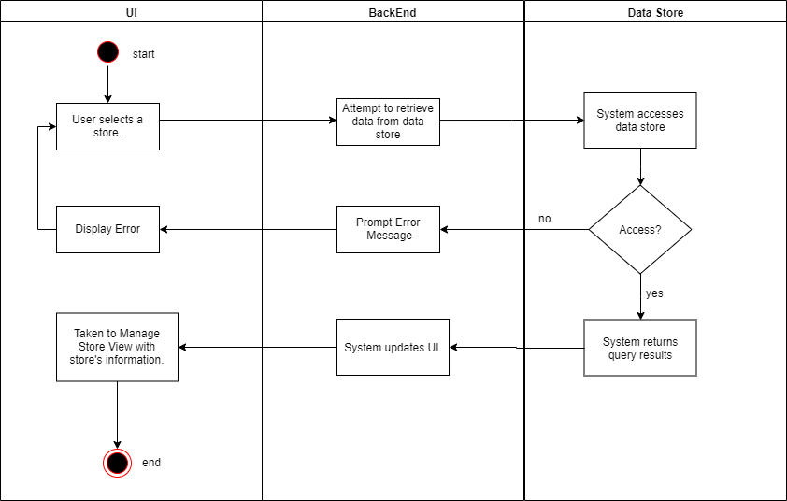

## Manage Store - Flag / Unflag An Ingredient In Their Store

Preconditions:

* User must be Store Owner.
* User must be on Manage Store View.

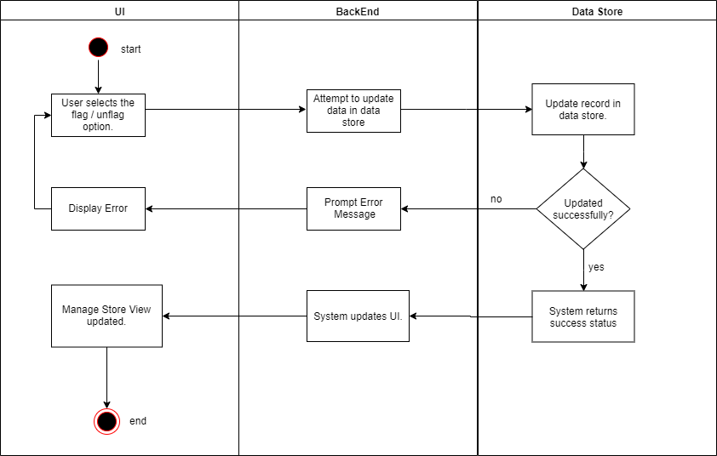

## Manage Store - Advertisement

Preconditions:

* User must be logged in and have Store Owner privileges.
* User must be at the Manage Store View.

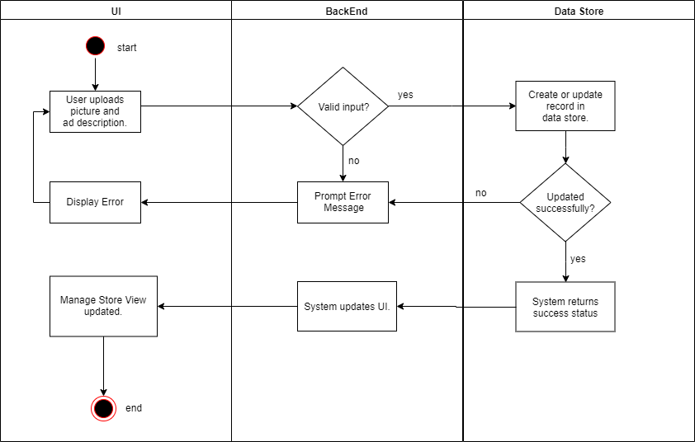

## Manage Store - Submit Description Of An Ingredient

Preconditions:

* User must be logged in with Store Owner privileges.
* User must be on the Manage Store View.

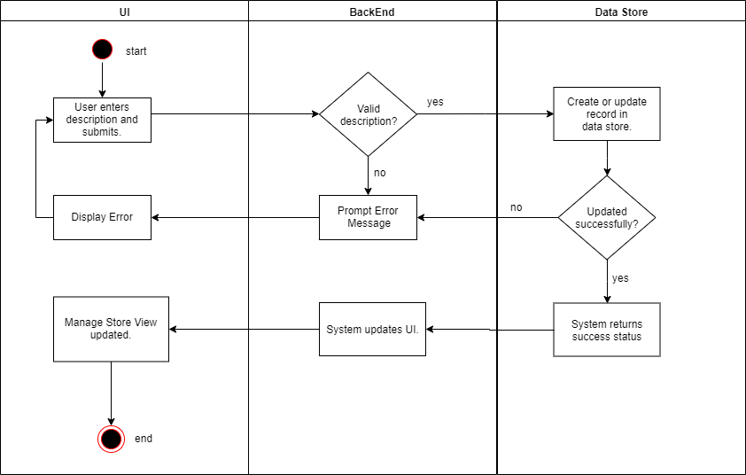

## Manage Store - Unclaim Store

Preconditions:

* User must be logged in and have Store Owner privileges.
* User must be on the Manage Store View.

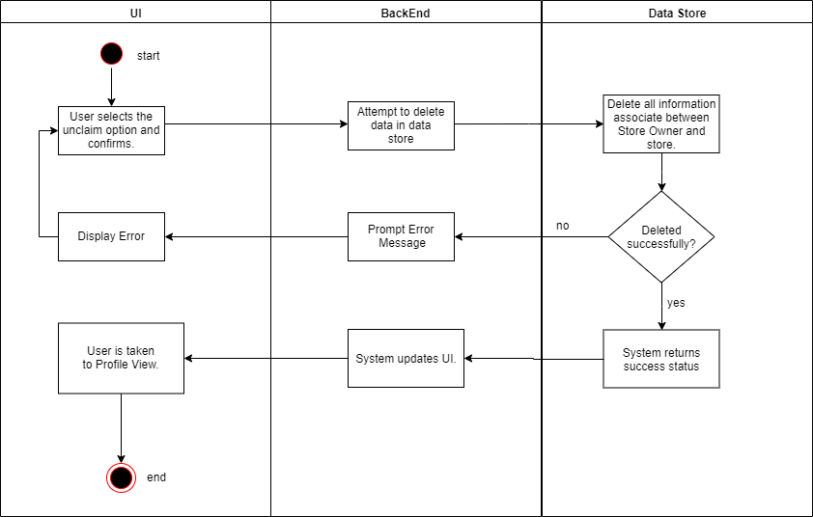

## Verify An Upload

Preconditions:

* User must be logged in and have Store Owner privileges.
* User must be on an Ingredient View for an ingredient from their store.

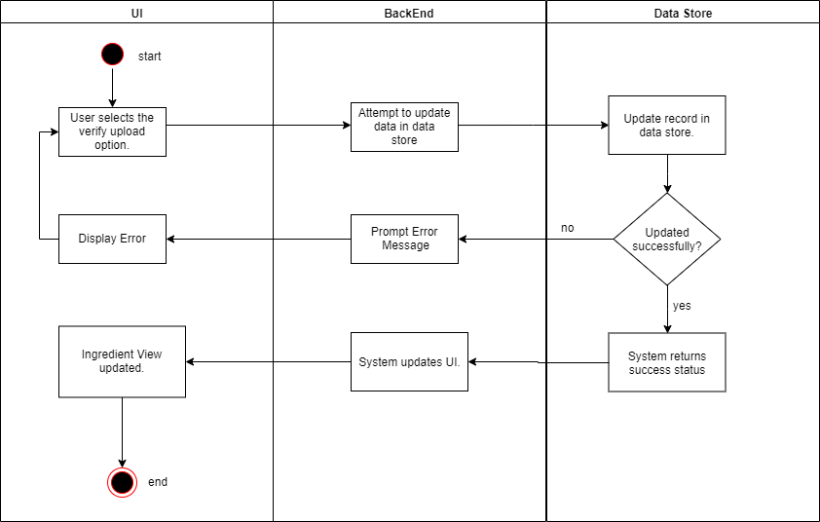

## Ingredient Save List - Add To Save List

Preconditions:

* User must be logged in.
* User must be at the Profile View.

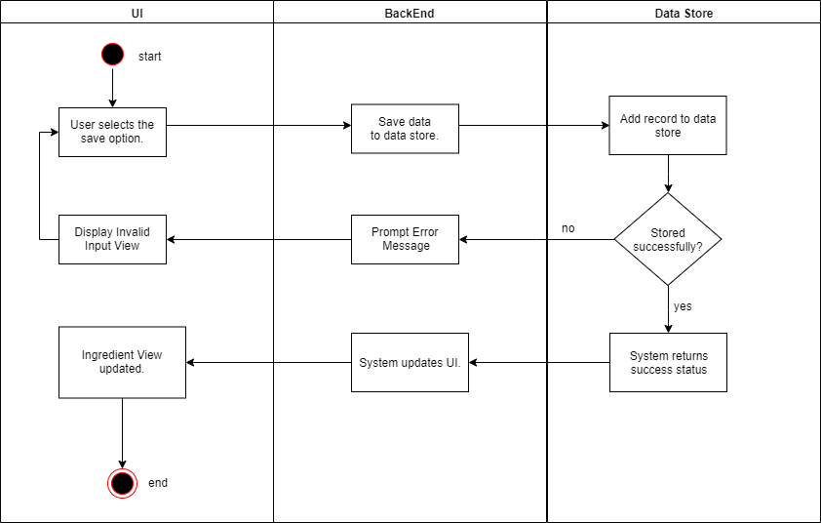

## Ingredient Save List - Delete From Save List

Preconditions:

* User must be logged in.
* User must have a saved item on their save list.
* User must be at the Profile View.

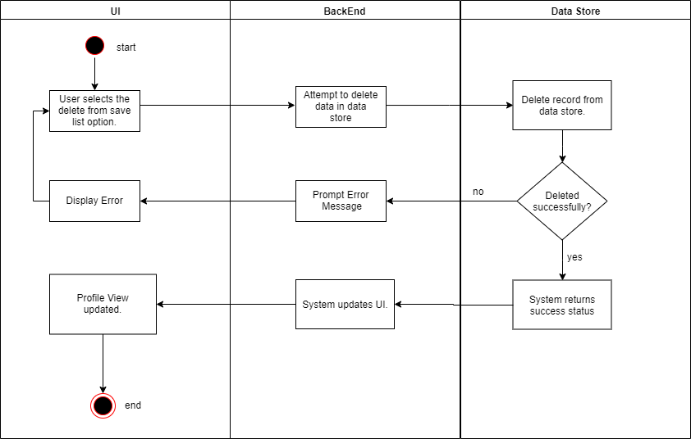

## Ingredient Save List - View Item From Save List

Preconditions:

* User must be logged in.
* User must have a saved item on their save list.
* User must be at the Profile View.

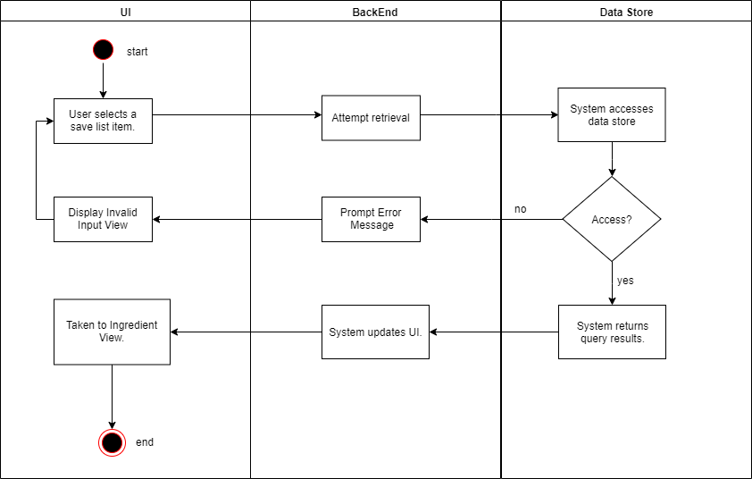

## Registration

Preconditions:

* User must not be logged in.

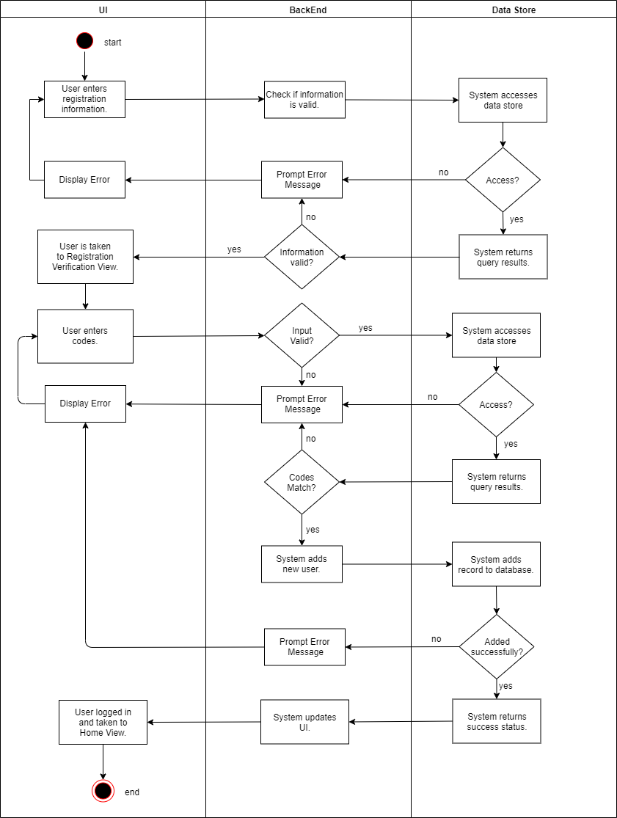

## Authentication - Login

Preconditions:

* User must be not logged in.
* User must have a registered account.

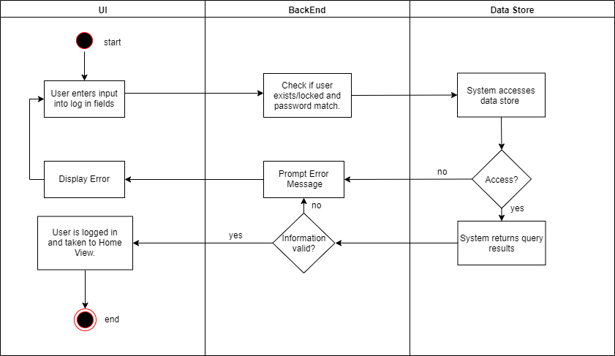

## Authentication - Logout

Preconditions:

* User must be logged in.

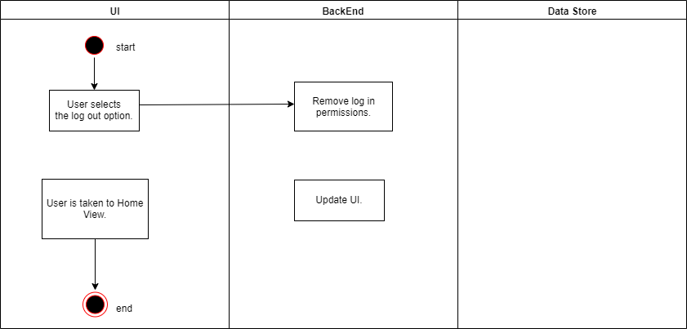

## Authentication - Reset Password

Preconditions:

* User must not be logged in to an account.
* User must be on Log In View.

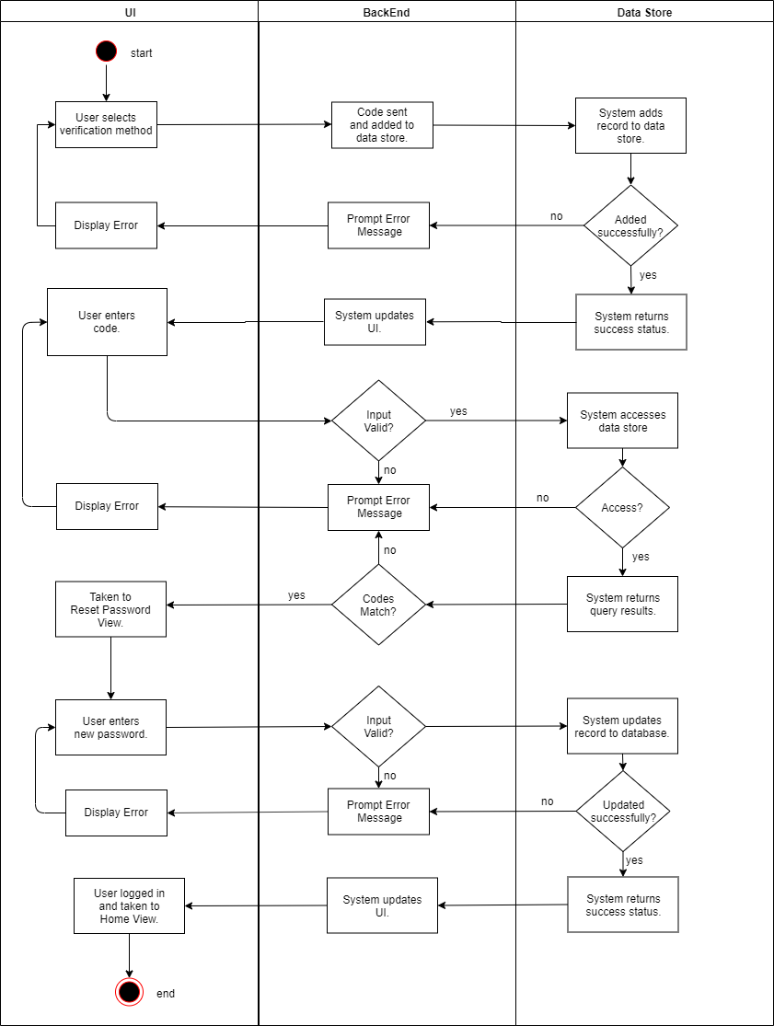

**THE FOLLOWING DIAGRAMS DO NOT INCLUDE UI, SO THEY WILL BE REPRESENTED AS ACTIVITY DIAGRAMS**

## Authorization

Preconditions:

* User attempts to interact with a feature.

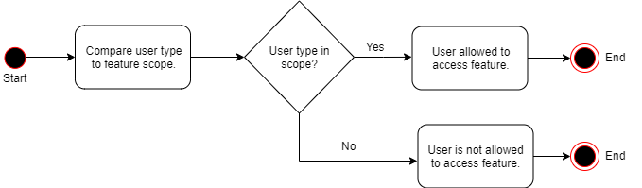

## Logging

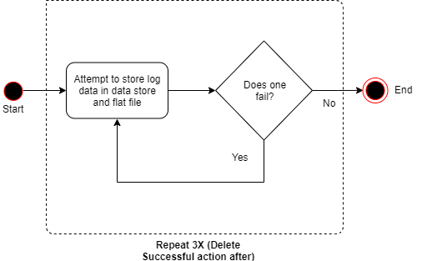

## Archiving

Preconditions:

* Access to logs, 30 days or older.

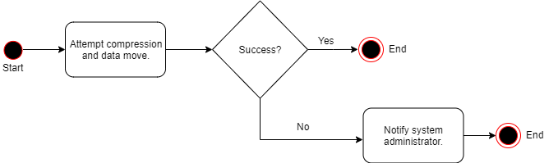

## Error Handling

Preconditions:

* A system error occurs.

